Study task

Market Segmentation Analysis

*Understanding It, Doing It, and Making It Useful*

By : Ujas Adepal

**INDEX**

Part 1 Introduction

Market Segmentation

Market Segmentation Analysis

Part 2 Part II Ten Steps of Market Segmentation Analysis

Step 1: Deciding (not) to Segment

Step 2: Specifying the Ideal Target Segment

Step 3: Collecting Data

Step 4: Exploring Data

Step 5: Extracting Segments.

Step 6: Profiling Segments.

Step 7: Describing Segments

Step 8: Selecting (the) Target Segment(s)

Step 9: Customising the Marketing Mix

Step 10: Evaluation and Monitoring

Part 1: Introduction - Market Segmentation

1. Strategic and Tactical Marketing
   * 1. Marketing planning is a logical sequence and a series of activities leading to the setting of marketing objectives and the formulation of plans to achieving them
     2. A marketing plan consists of two components: a strategic and a tactical marketing plan
        1. The strategic plan outlines the long-term direction of an organization, but does not provide much detail on short term marketing action required to move in this long-term direction.
        2. The tactical marketing plan does the opposite. It translates the long-term strategic plan into detailed instructions for short-term marketing action. The strategic marketing plan states where the organization wants to go and why. The tactical marketing plan contains instructions on what needs to be done to get there.
2. Definitions of Market Segmentation
   1. Market segmentation is a decision-making tool for the marketing manager in the crucial task of selecting a target market for a given product and designing an appropriate marketing mix. Market segmentation is one of the key building blocks of strategic marketing. Market segmentation is essential for marketing success: the most successful firms drive their businesses based on segmentation. Market segmentation lies at the heart of successful marketing, tools such as segmentation have the largest impact on marketing decisions.
3. The Benefits of Market Segmentation
   1. Market segmentation has a number of benefits. At the most general level, market segmentation forces organizations to take stock of where they stand, and where they want to be in future. In so doing, it forces organizations to reflect on what they are particularly good at compared to competitors, and make an effort to gain insights into what consumers want. Market segmentation offers an opportunity to think and rethink, and leads to critical new insights and perspectives.
4. The Costs of Market Segmentation
   1. Implementing market segmentation requires a substantial investment by the organization. A large number of people have to dedicate a substantial amount of time to conduct a thorough market segmentation analysis. If a segmentation strategy is pursued, more human and financial resources are required to develop and implement a customized marketing mix. Finally, the evaluation of the success of the segmentation strategy, and the continuous monitoring of market dynamics (that may point to the need for the segmentation strategy to be modified) imply an ongoing commitment of resources. These resource commitments are made under the assumption that the organization will benefit from a return on this investment. Yet, the upfront investment is substantial.

Part 1: Introduction - Market Segmentation Analysis

1. The Layers of Market Segmentation Analysis
   1. Market segmentation analysis, at its core, is the process of grouping consumers into naturally existing or artificially created segments of consumers who share similar product preferences or characteristics.
   2. This process is typically a statistical one. Yet, it is exploratory in nature. Many decisions made by the data analyst in the process of extracting market segments from consumer data affect the final market segmentation solution. For market segmentation analysis to be useful to an organisation, therefore, both a competent data analyst, and a user who understands the broader mission of the organisation (or that of their organisational unit when working in a team) need to be involved when market segments are extracted from consumer data.

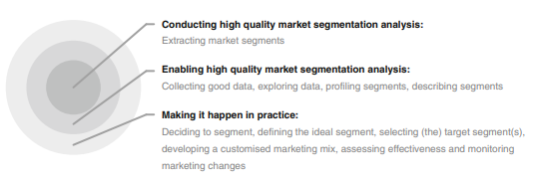

1. Approaches to Market Segmentation Analysis
   1. No one single approach is best when conducting market segmentation analysis. Instead, approaches to market segmentation analysis can be systematised in a number of different ways. We present two systematics here, one uses as its basis the extent to which the organisation conducting the market segmentation study is willing or able to make changes to their current approach of targeting the market or a segment of the market and has been proposed by Dibb and Simkin.
   2. Based on Organisational Constraints
      1. Dibb and Simkin (2008) distinguish three approaches to market segmentation: the quantitative survey-based approach, the creation of segments from existing consumer classifications, and the emergence of segments from qualitative research.
      2. These three approaches differ in how radical the resulting change is for the organisation. We refer to the approach requiring the most radical change in the organisation as segment revolution. It is like jumping on a sandcastle and building a new one. It starts from zero.
      3. A less radical approach is that of segment evolution, which is like refining an existing sandcastle. As long as the sandcastle is robust, and not too close to the water, this is a perfectly reasonable approach. The least radical approach is not really even a segmentation approach, it is like walking down the beach and seeing a huge pile of sand and thinking: this would make a fantastic sandcastle.
      4. It is a random discovery, like a mutation, which – if noticed and acted upon – also has the potential of allowing the organization to harvest the benefits of market segmentation.
   3. Based on the Choice of (the) Segmentation Variable(s)
      1. A more technical way of systematizing segmentation approaches is to use as a basis the nature of consumer characteristics used to extract market segments.
      2. Sometimes one single piece of information about consumers (one segmentation variable) is used.
      3. This statistical problem is unidimensional. One example is age. The resulting segments are age groups, and older consumers could be selected as a target segment.
2. Data Structure and Data-Driven Market Segmentation Approaches
   1. When conducting data-driven market segmentation, data analysts and users of market segmentation solutions often assume that market segments naturally exist in the data. Such naturally occurring segments, it is assumed, need to merely be revealed and described.
   2. In real consumer data, naturally existing, distinct and well separated market segments rarely exist.
3. Market Segmentation Analysis Step-by-Step
   1. The basic structure is the same for both commonsense and data-driven market segmentation: an organisation needs to weigh up the advantages and disadvantages of pursuing a segmentation strategy, and decide whether or not to go ahead (Step 1)
   2. Next, the organisation needs to specify characteristics of their ideal market segment
   3. Only after this preliminary and predominantly conceptual work is finalised, is empirical data collected or compiled from existing sources
   4. These data need to be explored
   5. before market segments are extracted
   6. The resulting market segments are profiled
   7. and described in detail
   8. is the point of no return where the organisation carefully selects one or a small number of market segments to target. Based on this choice, a customised marketing mix is developed
   9. Upon completion of the market segmentation analysis, the success of implementing a market segmentation strategy needs to be evaluated, and segments need to be continuously monitored
   10. for possible changes in size or in characteristics. Such changes may require modifications to the market segmentation strategy.

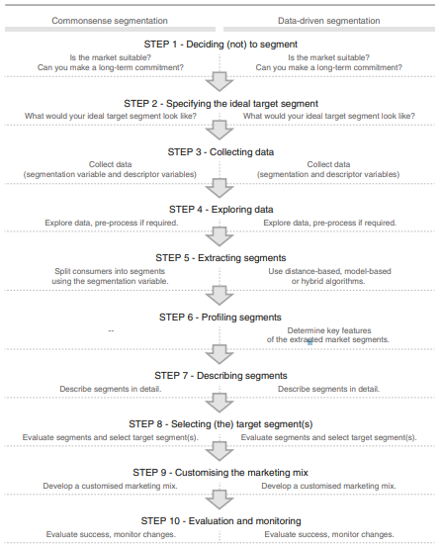

Part II Ten Steps of Market Segmentation Analysis

1. Step 1: Deciding (not) to Segment:
   1. Implications of Committing to Market Segmentation
      1. The key implication is that the organisation needs to commit to the segmentation strategy on the long term. Market segmentation is a marriage, not a date. The commitment to market segmentation goes hand in hand with the willingness and ability of the organisation to make substantial changes and investments
   2. Implementation Barriers
      1. The first group of barriers relates to senior management. Lack of leadership, pro-active championing, commitment and involvement in the market segmentation process by senior leadership undermines the success of market segmentation.
      2. A second group of barriers relates to organisational culture. Lack of market or consumer orientation, resistance to change and new ideas, lack of creative thinking, bad communication and lack of sharing of information and insights across organisational units, short-term thinking, unwillingness to make changes and office politics have been identified as preventing the successful implementation of market segmentation
      3. Another potential problem is lack of training. If senior management and the team tasked with segmentation do not understand the very foundations of market segmentation, or if they are unaware of the consequences of pursuing such a strategy, the attempt of introducing market segmentation is likely to fail.
      4. Another obstacle may be objective restrictions faced by the organisation, including lack of financial resources, or the inability to make the structural changes required
   3. Step 1 Checklist

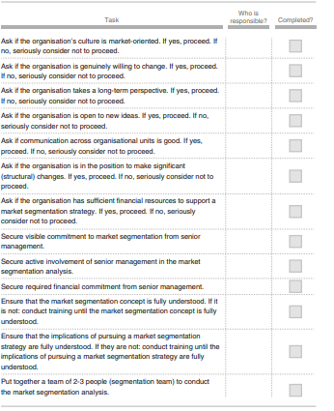

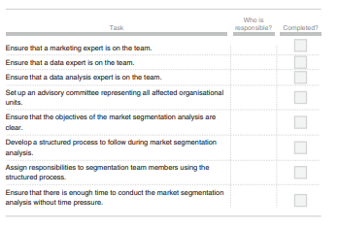

1. Step 2: Specifying the Ideal Target Segment
   1. Segment Evaluation Criteria
      1. The third layer of market segmentation analysis (illustrated in Fig. 2.1) depends primarily on user input\
      2. It is important to understand that – for a market segmentation analysis to produce results that are useful to an organisation – user input cannot be limited to either a briefing at the start of the process, or the development of a marketing mix at the end.
      3. Rather, the user needs to be involved in most stages, literally wrapping around the technical aspects of market segmentation analysis
   2. Knock-Out Criteria
      1. Knock-out criteria are used to determine if market segments resulting from the market segmentation analysis qualify to be assessed using segment attractiveness criteria
      2. The first set of such criteria was suggested by Kotler (1994) and includes substantiality, measurability and accessibility
      3. The segment must be homogeneous; members of the segment must be similar to one another.
      4. The segment must be distinct; members of the segment must be distinctly different from members of other segments.
      5. The segment must be large enough; the segment must contain enough consumers to make it worthwhile to spend extra money on customising the marketing mix for them.
      6. The segment must be matching the strengths of the organisation; the organisation must have the capability to satisfy segment members’ needs.
      7. Members of the segment must be identifiable; it must be possible to spot them in the marketplace.
      8. The segment must be reachable; there has to be a way to get in touch with members of the segment in order to make the customised marketing mix accessible to them.
   3. Attractiveness Criteria
      1. In addition to the knock-out criteria, also lists a wide range of segment attractiveness criteria available to the segmentation team to consider when deciding which attractiveness criteria are most useful to their specific situation
      2. Attractiveness criteria are not binary in nature. Segments are not assessed as either complying or not complying with attractiveness criteria. Rather, each market segment is rated; it can be more or less attractive with respect to a specific criterion
   4. Implementing a Structured Process
      1. There is general agreement in the segmentation literature, that following a structured process when assessing market segments is beneficial
      2. The most popular structured approach for evaluating market segments in view of selecting them as target markets is the use of a segment evaluation plot (Lilien and Rangaswamy 2003; McDonald and Dunbar 2012) showing segment attractiveness along one axis, and organisational competitiveness on the other axis
      3. Factors which constitute both segment attractiveness and organisational competitiveness need to be negotiated and agreed upon. To achieve this, a large number of possible criteria has to be investigated before agreement is reached on which criteria are most important for the organisation. McDonald and Dunbar (2012) recommend to use no more than six factors as the basis for calculating these criteria
   5. Step 2 Checklist

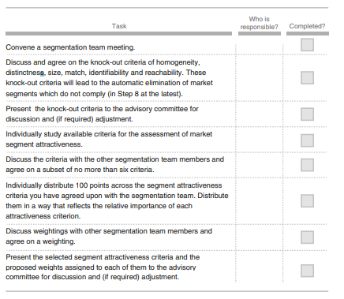

1. Step 3: Collecting Data
   1. Segmentation Variables
      1. Empirical data forms the basis of both commonsense and data-driven market segmentation. Empirical data is used to identify or create market segments and – later in the process – describe these segments in detail.
      2. personal characteristics available in the data – in this case: age, the number of vacations taken, and information about five benefits people seek or do not seek when they go on vacation – serve as so-called descriptor variables. They are used to describe the segments in detail.
   2. Segmentation Criteria
      1. Long before segments are extracted, and long before data for segment extraction is collected, the organisation must make an important decision: it must choose which segmentation criterion to use
      2. The term segmentation criterion is used here in a broader sense than the term segmentation variable
      3. Socio-Demographic Segmentation
      4. Psychographic Segmentation
      5. Behavioural Segmentation
   3. Data from Survey Studies
      1. Most market segmentation analyses are based on survey data. Survey data is cheap and easy to collect, making it a feasible approach for any organisation. But survey data – as opposed to data obtained from observing actual behaviour – can be contaminated by a wide range of biases.
      2. Choice of Variables
      3. Response Options
      4. Response Styles
      5. Sample Size
   4. Data from Internal Sources
      1. Increasingly organisations have access to substantial amounts of internal data that can be harvested for the purpose of market segmentation analysis.
      2. Typical examples are scanner data available to grocery stores, booking data available through airline loyalty programs, and online purchase data.
   5. Data from Experimental Studies
      1. Another possible source of data that can form the basis of market segmentation analysis is experimental data. Experimental data can result from field or laboratory experiments
   6. Step 3 Checklist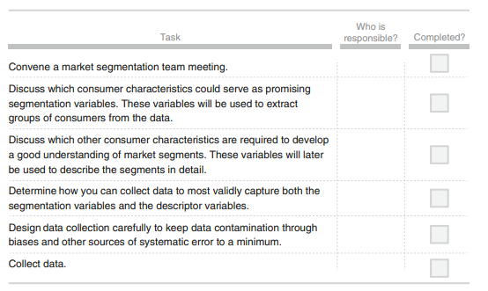
2. Step 4: Exploring Data
   1. A First Glimpse at the Data
      1. At a more technical level, data exploration helps to (1) identify the measurement levels of the variables; (2) investigate the univariate distributions of each of the variables; and (3) assess dependency structures between variables.
   2. Data Cleaning
      1. The first step before commencing data analysis is to clean the data. This includes checking if all values have been recorded correctly, and if consistent labels for the levels of categorical variables have been used
   3. Descriptive Analysis
      1. Being familiar with the data avoids misinterpretation of results from complex analyses. Descriptive numeric and graphic representations provide insights into the data. Statistical software packages offer a wide variety of tools for descriptive analysis.
   4. Pre-Processing
      1. Categorical Variables: Two pre-processing procedures are often used for categorical variables. One is merging levels of categorical variables before further analysis, the other one is converting categorical variables to numeric ones, if it makes sense to do so. 66 6 Step 4: Exploring Data Merging levels of categorical variables is useful if the original categories are too differentiated (too many)
      2. Numeric Variables: The range of values of a segmentation variable affects its relative influence in distance-based methods of segment extraction. To balance the influence of segmentation variables on segmentation results, variables can be standardised. Standardising variables means transforming them in a way that puts them on a common scale.
   5. Principal Components Analysis
      1. Principal components analysis (PCA) transforms a multivariate data set containing metric variables to a new data set with variables – referred to as principal components – which are uncorrelated and ordered by importance
      2. The first variable (principle component) contains most of the variability, the second principle component contains the second most variability, and so on
   6. Step 4 Checklist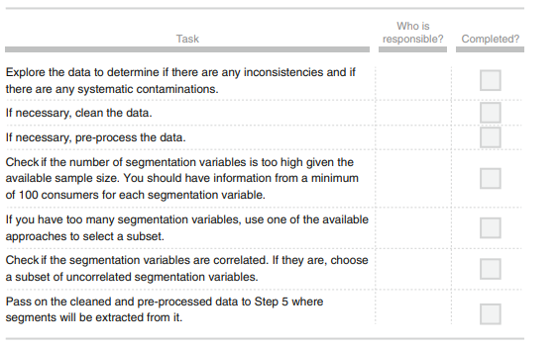
3. Step 5: Extracting Segments
   1. Grouping Consumers
      1. Data-driven market segmentation analysis is exploratory by nature. Consumer data sets are typically not well structured. Consumers come in all shapes and forms; a two-dimensional plot of consumers’ product preferences typically does not contain clear groups of consumers. Rather, consumer preferences are spread across the entire plot.
      2. The combination of exploratory methods and unstructured consumer data means that results from any method used to extract market segments from such data will strongly depend on the assumptions made on the structure of the segments implied by the method. The result of a market segmentation analysis, therefore, is determined as much by the underlying data as it is by the extraction algorithm chosen
   2. Distance-Based Methods
      1. Distance Measures: a typical data matrix. Each row represents an observation (in this case a tourist), and every column represents a variable (in this case a vacation activity). Mathematically, this can be represented as an n × p matrix where n stands for the number of observations (rows) and p for the number of variables (columns): 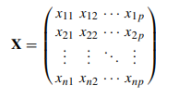
      2. Hierarchical Methods: Hierarchical clustering methods are the most intuitive way of grouping data because they mimic how a human would approach the task of dividing a set of n observations (consumers) into k groups (segments). the task of dividing a set of n observations (consumers) into k groups (segments). If the aim is to have one large market segment (k = 1), the only possible solution is one big market segment containing all consumers in data X. At the other extreme, if the aim is to have as many market segments as there are consumers in the data set (k = n), the number of market segments has to be n, with each segment containing exactly one consumer. Each consumer represents their own cluster. Market segmentation analysis occurs between those two extremes
      3. Partitioning Methods: Hierarchical clustering methods are particularly well suited for the analysis of small data sets with up to a few hundred observations. For larger data sets, dendrograms are hard to read, and the matrix of pairwise distances usually does not fit into computer memory.
      4. Hybrid Approaches: Several approaches combine hierarchical and partitioning algorithms in an attempt to compensate the weaknesses of one method with the strengths of the other. The strengths of hierarchical cluster algorithms are that the number of market segments to be extracted does not have to be specified in advance, and that similarities of market segments can be visualised using a dendrogram. The biggest disadvantage of hierarchical clustering algorithms is that standard implementations require substantial memory capacity, thus restricting the possible sample size of the data for applying these methods. Also, dendrograms become very difficult to interpret when the sample size is large.
   3. Model-Based Methods
      1. Finite Mixtures of Distributions: The simplest case of model-based clustering has no independent variables x, and simply fits a distribution to y. To compare this with distance-based methods, finite mixtures of distributions basically use the same segmentation variables: a number of pieces of information about consumers, such as the activities they engage in when on vacation. No additional information about these consumers, such as total travel expenditures, is simultaneously included in the model.
      2. Finite Mixtures of Regressions: Finite mixtures of distributions are similar to distance-based clustering methods and – in many cases – result in similar solutions. Compared to hierarchical or partitioning clustering methods, mixture models sometimes produce more useful, and sometimes less useful solutions. Finite mixtures of regression models (e.g., Wedel and Kamakura 2000; Bijmolt et al. 2004; Grün and Leisch 2007; Grün and Leisch 2008; Oppewal et al. 2010) offer a completely different type of market segmentation analysis. Finite mixture of regression models assume the existence of a dependent target variable y that can be explained by a set of independent variables x. The functional relationship between the dependent and independent variables is considered different for different market segments.
      3. Extensions and Variations: Finite mixture models are more complicated than distance-based methods. The additional complexity makes finite mixture models very flexible. It allows using any statistical model to describe a market segment. As a consequence, finite mixture models can accommodate a wide range of different data characteristics: for metric data we can use mixtures of normal distributions, for binary data we can use mixtures of binary distributions
   4. Algorithms with Integrated Variable Selection
      1. Most algorithms focus only on extracting segments from data. These algorithms assume that each of the segmentation variables makes a contribution to determining the segmentation solution. But this is not always the case. Sometimes, segmentation variables were not carefully selected, and contain redundant or noisy variables. Preprocessing methods can identify them.
      2. Biclustering Algorithms: Biclustering simultaneously clusters both consumers and variables. Biclustering algorithms exist for any kind of data, including metric and binary. This section focuses on the binary case where these algorithms aim at extracting market segments containing consumers who all have a value of 1 for a group of variables. These groups of consumers and variables together then form the bicluster.
      3. Variable Selection Procedure for Clustering Binary Data (VSBD): VSBD method is based on the k-means algorithm as clustering method, and assumes that not all variables available are relevant to obtain a good clustering solution. In particular, the method assumes the presence of masking variables. They need to be identified and removed from the set of segmentation variables. Removing irrelevant variables helps to identify the correct segment structure, and eases interpretation.
      4. Variable Reduction: Factor-Cluster Analysis: The term factor-cluster analysis refers to a two-step procedure of data-driven market segmentation analysis. In the first step, segmentation variables are factor analysed. The raw data, the original segmentation variables, are then discarded. In the second step, the factor scores resulting from the factor analysis are used to extract market segments.
   5. Data Structure Analysis
      1. Cluster Indices: Because market segmentation analysis is exploratory, data analysts need guidance to make some of the most critical decisions, such as selecting the number of market segments to extract. So-called cluster indices represent the most common approach to obtaining such guidance. Cluster indices provide insight into particular aspects of the market segmentation solution. Which kind of insight, depends on the nature of the cluster index used. Generally, two groups of cluster indices are distinguished: internal cluster indices and external cluster indices.
      2. Gorge Plots: A simple method to assess how well segments are separated, is to look at the distances of each consumer to all segment respresentatives.
      3. Global Stability Analysis: An alternative approach to data structure analysis that can be used for both distanceand model-based segment extraction techniques is based on resampling methods. Resampling methods offer insight into the stability of a market segmentation solution across repeated calculations. To assess the global stability of any given segmentation solution, several new data sets are generated using resampling methods, and a number of segmentation solutions are extracted.
      4. Segment Level Stability Analysis: Choosing the globally best segmentation solution does not necessarily mean that this particular segmentation solution contains the single best market segment. Relying on global stability analysis could lead to selecting a segmentation solution with suitable global stability, but without a single highly stable segment.
   6. Step 5 Checklist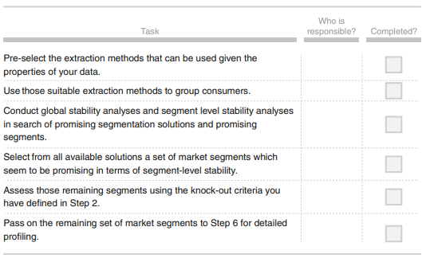
4. Step 6: Profiling Segments
   1. Identifying Key Characteristics of Market Segments
      1. The aim of the profiling step is to get to know the market segments resulting from the extraction step. Profiling is only required when data-driven market segmentation is used. For commonsense segmentation, the profiles of the segments are predefined.
   2. Traditional Approaches to Profiling Market Segments
      1. Data-driven segmentation solutions are usually presented to users (clients, managers) in one of two ways: (1) as high level summaries simplifying segment characteristics to a point where they are misleadingly trivial, or (2) as large tables that provide, for each segment, exact percentages for each segmentation variable.
   3. Segment Profiling with Visualisations
      1. Visualisations are useful in the data-driven market segmentation process to inspect, for each segmentation solution, one or more segments in detail. Statistical graphs facilitate the interpretation of segment profiles. They also make it easier to assess the usefulness of a market segmentation solution. The process of segmenting data always leads to a large number of alternative solutions. Selecting one of the possible solutions is a critical decision. Visualisations of solutions assist the data analyst and user with this task
      2. Identifying Defining Characteristics of Market Segments
      3. Assessing Segment Separation
   4. Step 6 Checklist 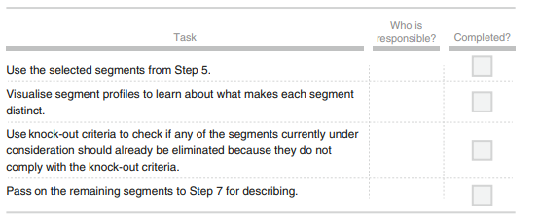
5. Step 7: Describing Segments
   1. Developing a Complete Picture of Market Segments
      1. Step 7 (describing segments) is similar to the profiling step. The only difference is that the variables being inspected have not been used to extract market segments. Rather, in Step 7 market segments are described using additional information available about segment members. If committing to a target segment is like a marriage, profiling and describing market segments is like going on a number of dates to get to know the potential spouse as well as possible in an attempt to give the marriage the best possible chance, and avoid nasty surprises down the track.
   2. Using Visualisations to Describe Market Segments
      1. A wide range of charts exist for the visualisation of differences in descriptor variables. Here, we discuss two basic approaches suitable for nominal and ordinal descriptor variables (such as gender, level of education, country of origin), or metric descriptor variables (such as age, number of nights at the tourist destinations, money spent on accommodation).
      2. Nominal and Ordinal Descriptor Variables
      3. Metric Descriptor Variables
   3. Testing for Segment Differences in Descriptor Variables
      1. Simple statistical tests can be used to formally test for differences in descriptor variables across market segments. The simplest way to test for differences is to run a series of independent tests for each variable of interest. The outcome of the segment extraction step is segment membership, the assignment of each consumer to one market segment. Segment membership can be treated like any other nominal variable
   4. Predicting Segments from Descriptor Variables
      1. Another way of learning about market segments is to try to predict segment membership from descriptor variables. To achieve this, we use a regression model with the segment membership as categorical dependent variable, and descriptor variables as independent variables. We can use methods developed in statistics for classification, and methods developed in machine learning for supervised learning.
      2. Binary Logistic Regression
      3. Multinomial Logistic Regression
      4. Tree-Based Methods
   5. Step 7 Checklist 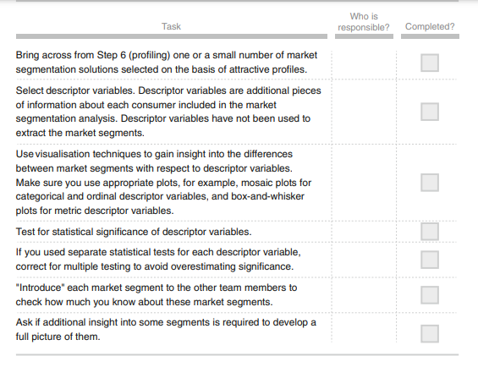
6. Step 8: Selecting the Target Segment(s)
   1. The Targeting Decision
      1. Step 8 is where the rubber hits the road. Now the big decision is made: which of the many possible market segments will be selected for targeting? Market segmentation is a strategic marketing tool. The selection of one or more target segments is a longterm decision significantly affecting the future performance of an organisation. This is when the flirting and dating is over; it’s time to buy a ring, pop the question, and commit.
   2. Market Segment Evaluation
      1. the two criteria plotted along the axes cover two dimensions: segment attractiveness, and relative organisational competitiveness specific to each of the segments. Using the analogy of finding a partner for life: segment attractiveness is like the question Would you like to marry this person? given all the other people in the world you could marry. Relative organisational competitiveness is like the question Would this person marry you? given all the other people in the world they could marry
   3. Step 8 Checklist 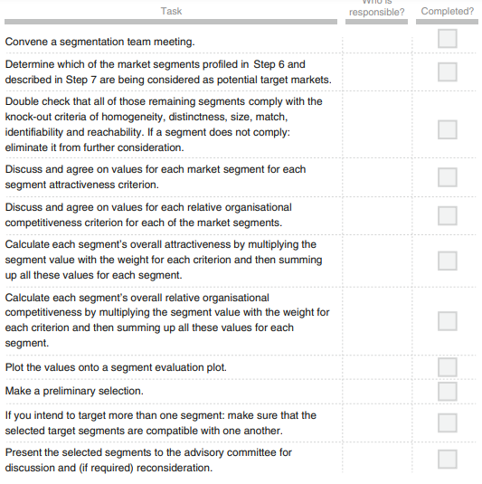
7. Step 9: Customizing the Marketing Mix
   1. Implications for Marketing Mix Decisions
      1. Borden (1964) postulated that marketers have at their disposal 12 ingredients: product planning, packaging, physical handling, distribution channels, pricing, personal selling, branding, display, advertising, promotions, servicing, fact finding and analysis. Many versions of this marketing mix have since been proposed, but most commonly the marketing mix is understood as consisting of the 4Ps: Product, Price, Promotion and Place 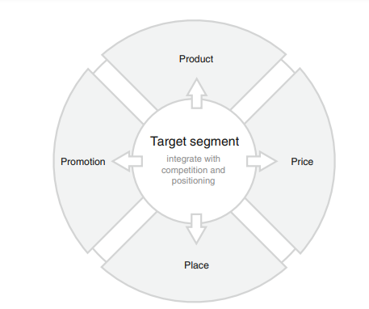
   2. Product
      1. One of the key decisions an organisation needs to make when developing the product dimension of the marketing mix, is to specify the product in view of customer needs. Often this does not imply designing an entirely new product, but rather modifying an existing one. Other marketing mix decisions that fall under the product dimension are: naming the product, packaging it, offering or not offering warranties, and after sales support services.
   3. Price
      1. Typical decisions an organisation needs to make when developing the price dimension of the marketing mix include setting the price for a product, and deciding on discounts to be offered.
   4. Place
      1. The key decision relating to the place dimension of the marketing mix is how to distribute the product to the customers. This includes answering questions such as: should the product be made available for purchase online or offline only or both; should the manufacturer sell directly to customers; or should a wholesaler or a retailer or both be used.
   5. Promotion
      1. Typical promotion decisions that need to be made when designing a marketing mix include: developing an advertising message that will resonate with the target market, and identifying the most effective way of communicating this message. Other tools in the promotion category of the marketing mix include public relations, personal selling, and sponsorship.
   6. Step 9 Checklist 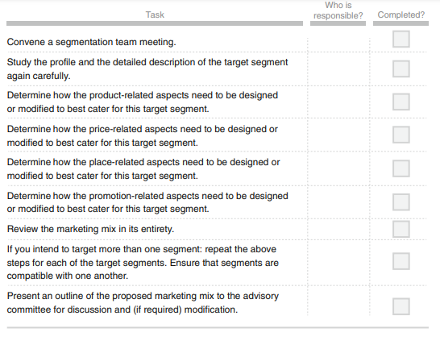
8. Step 10: Evaluation and Monitoring
   1. Ongoing Tasks in Market Segmentation
      1. Market segmentation analysis does not end with the selection of the target segment, and the development of a customised marketing mix : The world changes . . . virtually the only practical option for an intelligent marketer is to monitor his or her market continuously
   2. Evaluating the Success of the Segmentation Strategy
      1. The aim of evaluating the effectiveness of the market segmentation strategy is to determine whether developing a customised marketing mix for one or more segments did achieve the expected benefits for the organisation.
   3. Stability of Segment Membership and Segment Hopping
      1. Changes in segment membership are problematic if (1) segment sizes change (especially if the target segment shrinks), and if (2) the nature of segments changes in terms of either segmentation or descriptor variables. Changes in segment size may require a fundamental rethinking of the segmentation strategy. Changes in segment characteristics could be addressed through a modification of the marketing mix.
   4. Segment Evolution
      1. Segments evolve. Like any characteristic of markets, market segments change over time. The environments in which the organisation operates, and actions taken by competitors change. Haley (1985), the father of benefit segmentation, says that not following-up a segmentation study means sacrificing a substantial part of the value it is able to generate
   5. Step 10 Checklist 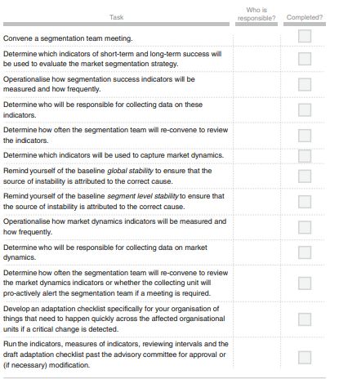

Github link for project implementation:

https://github.com/ujasadepal2222222222/Market-Segmentation-Analysis-Study-Task-s